**Admin Panel**

***Updated 30.06.2015***

1. News

* Edit News – Image disappears after edit?=>**not yet fixed?**

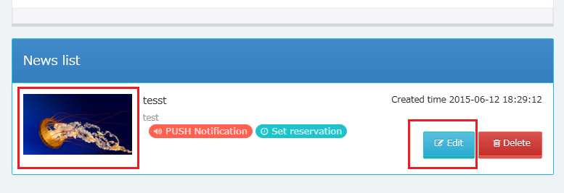

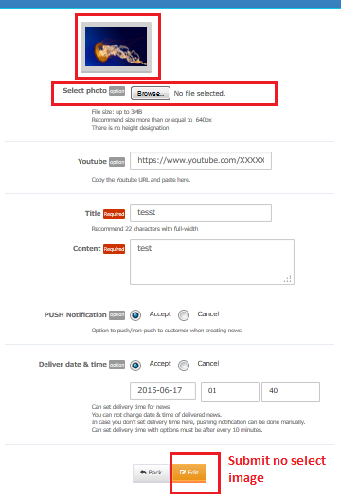

* **Step2: Text Title strlen has been trim <= 11 => new bug**

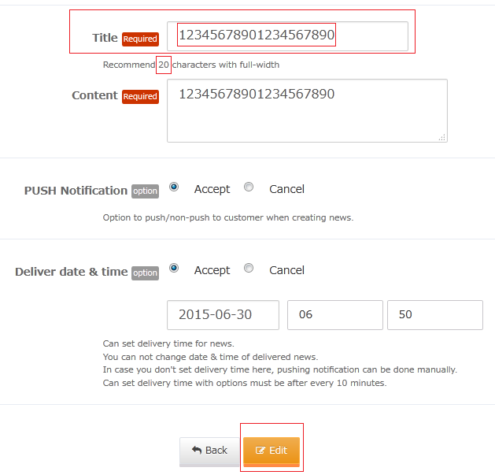

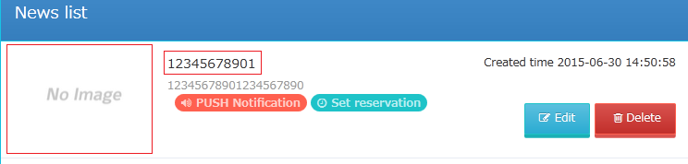

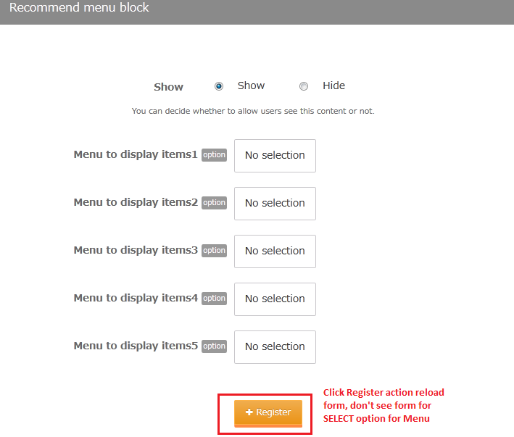

1. Top preview: error preview from Store to Map => **new bug**

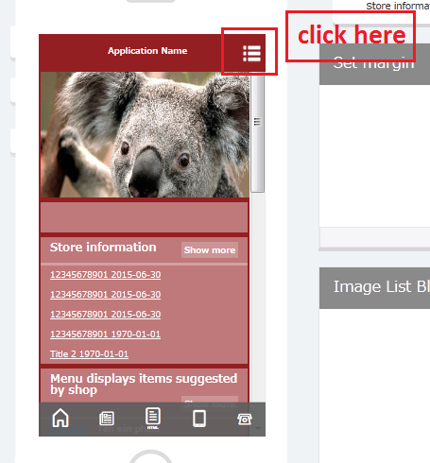

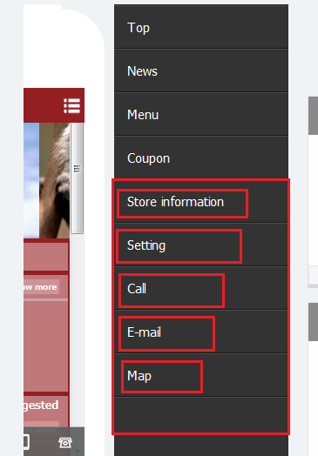

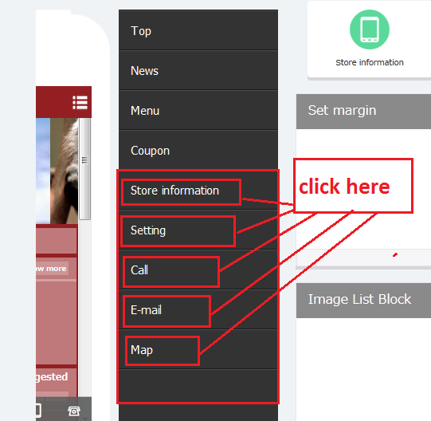

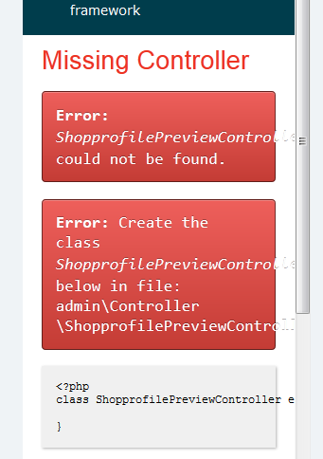

**API**

1. **API questions:**
2. You have used multi-languages for all API right?
3. Only **sidemenu** api follow multi-languages or all API follow multi-languages?
4. Why we call any 1 API then auto create 1 record into DB for default language **lang = en-us?**